**Discussion 1.1 – Database Diagrams**

Patrick Cuauro

Bellevue University

WEB 335-307O Introduction to NoSQL

Professor Krasso

May 25, 2023

## What are database diagrams?

Database diagrams graphically show the structure of the database and relations between database objects. You can generate a diagram for a data source, a schema, or a table. To create relations between database objects, consider using primary and foreign keys.

A primary key contains unique values and identifies each row in a table.

For some databases, the primary key cannot contain NULL values. A table can have only one primary key and this primary key can consist of single or multiple columns. When a primary key consists of multiple columns, the data from these columns is used to determine whether a row is unique.

Foreign key relationships specify how tables relate to each other and indicate relationships between tables.

## Why are database diagrams used?

They represent the data in a graphical manner. This makes it easier for business folks to understand.

## What is an Entity Relationship Diagram?

An entity-relationship diagram, or ER diagram, is essential for modeling the data stored in a database. It is the basic design upon which a database is built. ER diagrams specify what data we will store: the entities and their attributes. They also show how entities relate to other entities.

## What tools can be used to create an ERD?

There are many database diagramming tools that are not only incredibly useful but also free. And these tools can help you shape your thinking and create a solid foundation for the rest of your data stack, from your database to BI tools.

## What are the symbols used in an ERD?

Entity Relationship Diagram Symbols & Notations mainly contains three basic symbols which are rectangle, oval and diamond to represent relationships between elements, entities, and attributes. There are some sub-elements which are based on main elements in ERD Diagram. ER Diagram is a visual representation of data that describes how data is related to each other using different ERD Symbols and Notations.

Following are the main components and its symbols in ER Diagrams:

* Rectangles: This Entity Relationship Diagram symbol represents entity types
* Ellipses: Symbol represent attributes
* Diamonds: This symbol represents relationship types
* Lines: It links attributes to entity types and entity types with other relationship types
* Primary key: attributes are underlined.
* Double Ellipses: Represent multi-valued attributes.

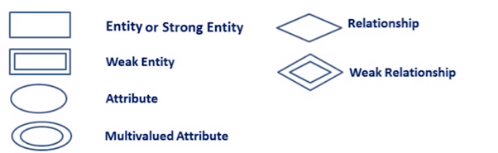

Sources: <https://www.jetbrains.com/help/phpstorm/creating-diagrams.html#:~:text=Database%20diagrams%EF%BB%BF&text=Database%20diagrams%20graphically%20show%20the,using%20primary%20and%20foreign%20keys>.

<https://chartio.com/learn/databases/7-free-database-diagramming-tools-for-busy-data-folks/>

<https://www.guru99.com/er-diagram-tutorial-dbms.html#:~:text=Entity%20Relationship%20Diagram%20Symbols%20%26%20Notations,between%20elements%2C%20entities%20and%20attributes>.